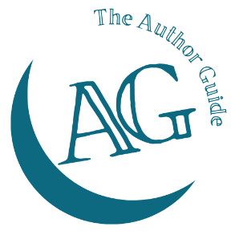
The Author Guide Course
for non-fiction authors

Focus worksheet

What’s important to my reader?

What’s important to me?

What’s important to me (continued)

The big takeaway

