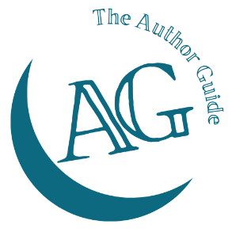
The Author Guide Course
for non-fiction authors

Reader profile worksheet
Know your reader – and your book will be highly focused and easier to market. Complete this worksheet and your reader avatar will be crystal clear.

1: The subject of your book

2: Personal demographics
It’s impossible to focus on ‘a reader’, you’ll need an actual person – with a name – that you can imagine clearly. They’re going to be your writing muse as your book develops. If you know someone who fits your ideal, then use them. If you don’t have a specific person in mind, create one in your imagination.
Gender
Age
Name

3: What details are common to all the readers that your book is for?
If you’re writing for business readers these might be:
- The industry they’re in
- The size of company
- Their geographical location
- The number of staff they have
- Their annual turnover
- Their skill set
Or if you’re writing about personal issues it might be:
- The size of their family
- Their job or career
- Their hobbies or leisure pursuits
- Their affiliations (membership of communities - online and offline)
- Their lifestyle
What you’re looking for is the defining factors for all the people who will really appreciate the content in your book and will benefit from it.

What are the defining factors of your readers?

4: Their personal style
For business readers this might be something like ‘sales mover and shaker’ or ‘financial wizard’ or ‘people developer’.
For personal readers it could be ‘environmentally aware’ or ‘party animal’ or ‘lover of fine living’.

Personal style
Are they movers and shakers, or planners and thinkers? What do they like doing? What do they avoid?

5: What influences them?
If you know what they read - online and offline, it’s going to be much easier to put your book in front of them.
This will include industry blogs they read, online and offline groups/forums they belong to, social media platforms they’re active on and industry/specialist journals they subscribe to. Who do they follow?

Influences

6: What keeps them awake at night?
What problems plague them? What do they want, but can’t find or don’t have at present? What do they want to do, but don’t know where or how to start? What causes them stress? Are they personal, skill-based, financial, people-related issues?

Worries

7: What are the barriers that they have come up against so far?
These might be described as reasons – or excuses – for not tackling these worries. What are their ‘reasons why not’?

Reasons for not taking action yet

Now you have all the information you need, write a short paragraph the describes your reader in as much detail as possible.

