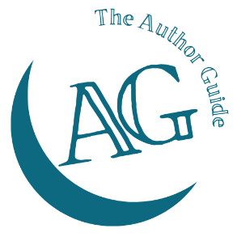
The Author Guide Course
for non-fiction authors

Your purpose worksheet

I am writing this book because …

My core message for my reader is …

