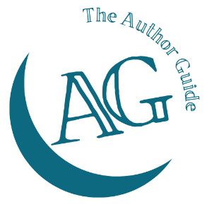
The Author Guide Course
for non-fiction authors

The Book Proposal worksheet
An agent (and a traditional publisher) will expect you to have done your preparation before pitching your book to them. You’ll need to be able to provide answers to the questions a publisher will ask them when they pitch your book. Completing this worksheet will give you the material you’ll need.

What is your book about?

What kind of book is it? (e.g. a tips book, a manual or guide, a text book, an autobiographical book)

What qualifies you to write about this?

Who is your book for (your ideal reader)?

Why would they want to read your book?

Where would you find these readers and get your book in front of them?

Broadly speaking what is each chapter about?

What kind of content will you be including? (e.g. case studies, anecdotes, models, quotations, examples, activities for the reader, stories, other people’s research/findings, etc.)

How many words do you expect it to be?

Which formats do you want it to be available in? (ebook, paperback, hardback, etc.)

What ideas do you have for your title?

What will your subtitle be?

What makes your book different – its WOW factor?

Which category (or categories) does your book fit into? (e.g. self-help, management, personal development, marketing, sport, ecommerce, business, etc.)

Which other authors have written books in this genre?

Will you have any graphics within the book? If so, provide brief details.

Are you planning to have a Foreword? Who will write this?

Do you have a pre-print list of people who will be willing to write reviews?

How do you plan to market your book?

