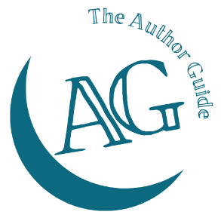
The Author Guide Course
for non-fiction authors

Chapter development worksheet
You’ll need to complete one of these for each chapter.
The Elements are the same for every chapter – from your Chapter structure worksheet. The Details are a note about what that element is for THIS chapter.
Chapter ____________________
Element | Details

