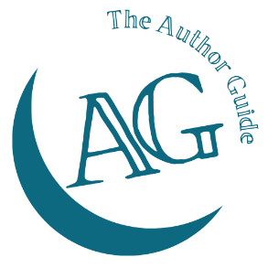
The Author Guide Course
for non-fiction authors

Chapter plan worksheet
Chapter | Main subject | Additional info
1
2
3
4
5
6
7
8
9
10
11
12
13
14
15

