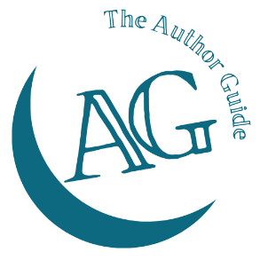
The Author Guide Course
for non-fiction authors

Chapter Structure worksheet
What will each chapter in your book include? E.g. story, quotation, summary, etc.
See your notes for some ideas, but don’t let that list restrict you, if you have other elements you want to add.

Is this the order these will appear in each chapter? If not reorder the list until you have a final order that you will apply to each chapter.

