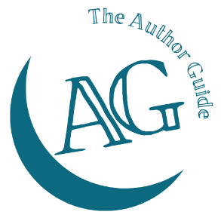
The Author Guide Course
for non-fiction authors

Bonus bundle worksheet
What will you include in your bonus bundle?
Item (e.g. download/webinar /draw/etc.) | Title/subject | Value

Total bundle value:

