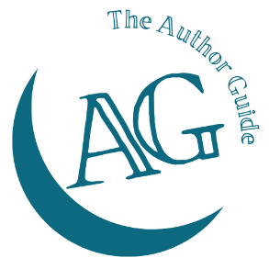
The Author Guide Course
for non-fiction authors

Pricing research worksheet
Will your book be:
Hardback
Paperback
eBook
Audio-book

Books similar to yours, published within the last 12 months
Book name | Author | No of pages | Hardback/ paperback price | Ebook price

