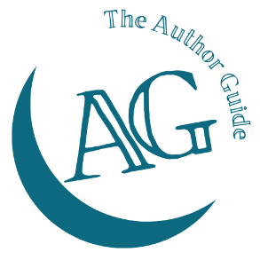
The Author Guide Course
for non-fiction authors

Promotion Tools worksheet

Media – print/digital
Potential article titles

Publication targets
Title | email

Media – broadcast

Podcast hosts
Podcast name | Host | email

Local radio
Station | Host/producer | Email/phone

YouTube channels
Channel | Host | Email/phone

Speaking
Include networking groups, associations, institutes, professional bodies, conference organisers, meeting planners, etc.
Group/Organisation | Contact | Email/phone

Joint venture partners
Company | Contact | Email/phone

